|  |  |  |  |  |  |  |  |  |  |  |  |  |  |  |  |  |  |  |  |  |  |  |  |  |  |  |  |  |  |  |  |  |  |  |
| --- | --- | --- | --- | --- | --- | --- | --- | --- | --- | --- | --- | --- | --- | --- | --- | --- | --- | --- | --- | --- | --- | --- | --- | --- | --- | --- | --- | --- | --- | --- | --- | --- | --- | --- |
| **INTERSTATE CONTAINER CORPORATION** | | | ***Date:* 08/08/2016** | ***Spec #:*** | | | | | | | | | | |  |  |  |  | ***Design #:*90786-02_C** | | | | | | | | | | | | | |  |  |
|  |  |  |  |  |  |
| ***Customer:*** | **DeMet's Candy** |  |  |  |  |  |  |  |  |  |  |  |  |  |  |  |  |  |  |  |  |  |  |  |  |  |  |  |  |  |  |  |  |  |
|  |  |  |  |  |  |  |  |  |  |  |  |  |  |  |  |  |  |  |  |  |  |  |  |  |  |  |  | ***Cut*** | **246 in.** | |  |  |
|  |  |  |  |  |  |  |  |  |  |  |  |  |  |  |  |  |  |  |  |  |  |  |  |  |  |  |  |  |  |
| ***Description:*** | **TRY. 502/3** |  |  |  |  |  |  |  |  |  |  |  |  |  |  |  |  |  |  |  |  |  |  |  |  |  |  |  |  |  |  |
|  |  |  |  |  |  |  |  |  |  |  |  |  |  |  |  |  |  |  |  |  |  |  |  |  |  |  |  | ***Crease*** | **149 in.** | |  |  |
|  |  |  |  |  |  |  |  |  |  |  |  |  |  |  |  |  |  |  |  |  |  |  |  |  |  |  |  |  |  |
| ***Style:* TRAY, NJDC** |  | ***Revision Info:* [C] 08/08/2016:new caddy size - Revised CUST. EPS FILE** | | | |  |  |  |  |  |  |  |  |  |  |  |  |  |  |  |  |  |  |  |  |  |  |  |  | ***3/8 3/8 combo perf score*** | **18 in.** | |  |  |
|  |  |  |  |  |  |  |  |  |  |  |  |  |  |  |  |  |  |  |  |  |  |  |  |  |  |  |
|  |  | **8/8/16 AG** | |  |  |  |  |  |  |  |  |  |  |  |  |  |  |  |  |  |  |  |  |  |  |  |  |  |  |  |  |  |  |  |
| ***I.D. :* 17 x 13+3/8 x 7+13/16** | | ***Blank size:* 50+1/8 x 34+7/16** |  |  |  |  |  |  |  |  |  |  |  |  |  |  |  |  |  |  |  |  |  |  |  |  |  |  |  |  |  |  |  |  |
| ***Board:* 32 B K** |  | ***Combination:* 35HP - 23M - 35HP** | ***Designer:* Customer Supplied** | | |  |  |  |  |  |  |  |  |  |  |  |  |  |  |  |  |  |  |  |  |  |  |  |  |  |  |  |  |  |
|  |  |  |  |  |  |  |  |  |  |  |  |  |  |  |  |  |  |  |  |  |  |  |  |  |  |  |  |  |  |

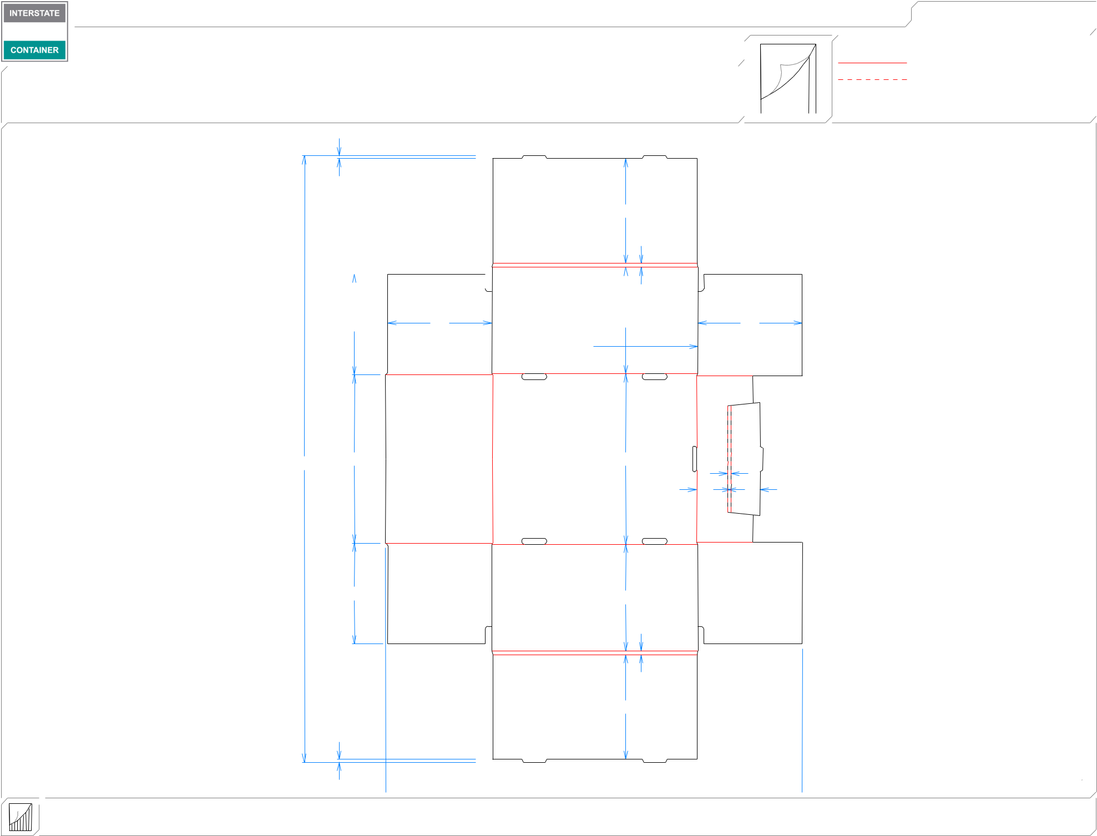

1*/*4

811*/*16

5*/*16

|  |  |  |  |  |  |
| --- | --- | --- | --- | --- | --- |
|  |  |  |  |  |  |
|  |  |  |  |  |  |
|  |  |  |  |  |  |
| 85 | | */*16 | 85*/*8 | 813*/*16 | |

 171*/*16

85*/*8

|  |  |  |
| --- | --- | --- |
| 501*/*8 | 1315*/*16 | 141*/*16 |
|  |  | 1*/*4 |
|  |  | 29*/*16 23*/*8 |

 87*/*8  167*/*8 

 85*/*8  171*/*16  85*/*8 

|  |  |
| --- | --- |
| 85*/*16 | 813*/*16 |

5*/*16

811*/*16

1*/*4  347*/*16 

**inside view**

**Vertical Corrugation**

***notes:***

***Qty/unit:*** ***Area - waste:* 9.14 sq. ft** ***Waste on blank:* 23.5%** ***Piece weight - waste:* 0.95 lbs./429.05 g**